Accumulation registers
The purpose of the accumulation register is to collect numerical data for different sets of measurements (dimensions). Let's consider an example with the "Goods in warehouses" register, which serves to ensure that at any point in time it is possible to obtain the balances of certain goods in a certain warehouse.
Let's consider an example with the "Goods in warehouses" register, which serves to ensure that at any point in time it is possible to obtain balances by quantity and amount for certain goods in a certain warehouse.
This can be useful for several reasons, for example, the user wants to view a report on the balances of the warehouse for which he is responsible, analyze the upcoming shortage of goods and order it. Another example - during a sales operation, the program should check whether the specified quantity of goods is available in the warehouse; if not, the program should display an error and prevent posting of the document.
Someone may have a question: “Why do we need a register for these purposes, since the balance (or movement) of goods can be calculated from documents?”. Let's take a look at the main reasons why calculating balances from document data is inferior in convenience and quality to the use of accumulation registers.
Firstly, the balance of goods in warehouses can be influenced by several different types of documents:
- “Purchase invoice”, “Movement of goods”, “Inventory capitalization” increase balances
- “Sales”, “Movement of goods”, “Inventory write-off” reduce balances.
And this list of documents can expand over time, then in each such case the algorithm for calculating product balances will have to be changed.
The business-process by which a document affects balances may also change. For example, over time, a Status attribute with the options “Draft”, “Under approval”, “Approved”, “Declined” will be added to the Sales document. Since that change the Sales document should reduce balances only if its status is “Approved”, in which case the algorithm for calculating balances will become even more complicated.
Secondly, the complexity of the calculation will increase with the increase of the number of documents, so if 50 thousand documents are entered per year, then after 5 years of working in the program you will have to collect data on 250 thousand documents, which will create an excessive load on the machine where the code will be executed.
As we learned earlier, a register is a table where records contain numerical data for sets of measurements (dimensions). For example, when posting a purchase document for the "Main" warehouse with goods
"Scotch tape 10m" in the amount of 100 pieces for the amount of 1000
"Stationery scissors" in the amount of 50 pieces for the amount of 250
we need to add 2 records to the register:
# | Product | Warehouse | Quantity | Amount
1 | Scotch tape 10m | Main | 100 | 1000
2 | Stationery scissors | Main | 50 | 250

Accumulation register records are subordinate to documents that are recorders of that register, which means that records cannot be added, modified or deleted directly, it can be done only by changing the document that affects the register.
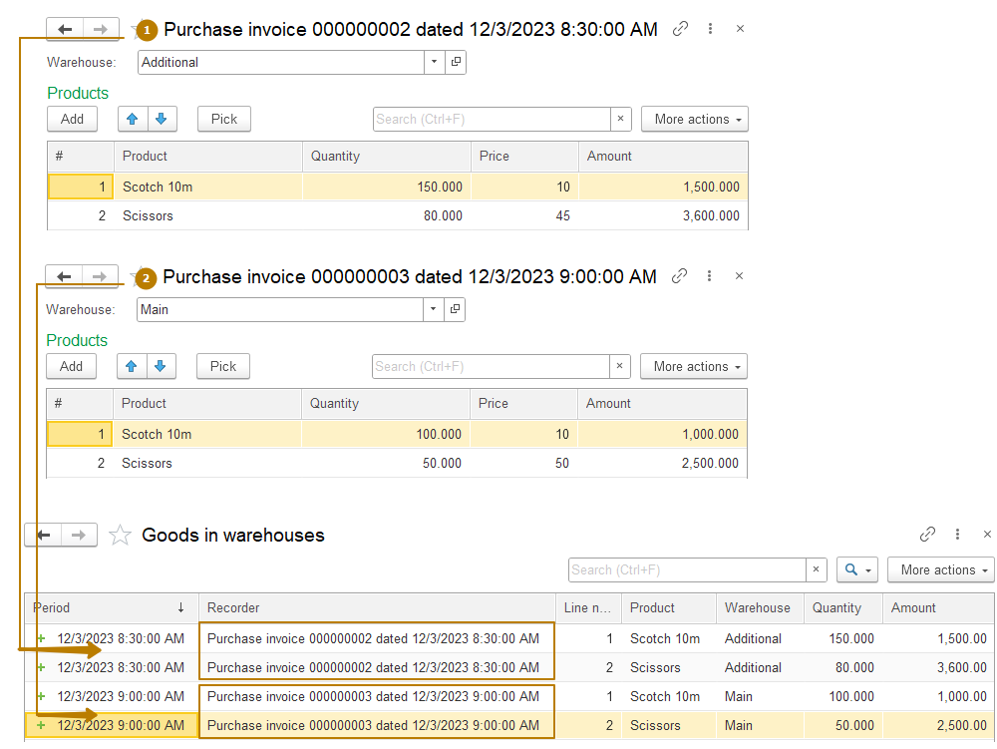
In the image above you can see that the product and warehouse are the data by which quantity and amount are recorded - these are register dimensions. The quantity and amount themselves are what we accumulate in the register - these are register resources. The register also has a separate type of objects for storing additional information of each record - these are register attributes.
Now we can obtain various information from such a register, for example:
- remaining goods “Scotch 10m” in Main warehouse
- remaining goods “Scissors” in all warehouses (without filter by warehouse)
- the amount of all goods in the warehouse Additional
In the case when the register consists of records such as in the image above, the results of such balances will be as follows:
- Scotch 10m - Main - 100 - 1000
- Scissors - 130 - 6100
- Additional - 5100
But in addition to obtaining information about balances, there is also a need to calculate turnovers for a period. For example, a fairly common practice in trade is to provide a discount for the volume of purchases. So, if a certain amount is exceeded during a certain period (month, quarter, year), the customer receives a discount until the end of this period or for the entire next period. In this case, the Balance table cannot help us, and calculating the turnovers from the table of movements (records) may be too slow for large amounts of data.
Accumulation registers have the “Register kind” property with possible values of “Balances” and “Turnovers”. For the above case, the register type "Turnover" is used. From such a register we can quickly obtain turnovers for a certain period or for the entire period from the first to the last register record. So, in our case we should create a Sales register with the Turnovers register kind, add the Counterparty dimension and Amount resource, which we will use to reflect all settlements with clients. Then at any time we can access the Turnover table to get the amount of all sales to a given client for the selected period.
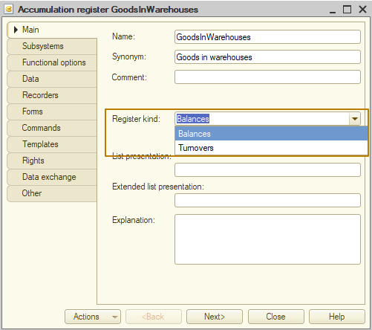
Next, let's look into the internal structure of the accumulation registers. In addition to real tables in 1C, there are also virtual tables. A real table contains data from a single physical table. A virtual table is formed at the time of query execution and can receive data from one or more physical database tables.
As we have already said, there are 2 kinds of accumulation register: Balances and Turnovers. The composition (as well as the mechanism) of virtual tables for such registers is different; a register of the “Balances” kind has 3 virtual tables:
- Balance,
- Turnovers,
- BalanceAndTurnovers;
and a register of the “Turnovers” kind has one virtual table
- Turnovers.
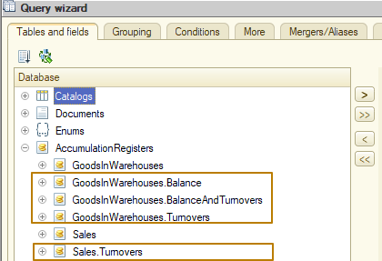
Next, we will look at the purpose and structure of each of the virtual tables, as well as the physical tables for both kinds of accumulation register.
An accumulation register of any kind at the database level stores data in two physical tables: a movement table and a totals table, however, the totals tables for balances register and turnovers register are different. The movement table simply contains all the records that were placed in it as a result of document posting.
Balance register tables
The totals table (physical table of a database) stores balances in the context of all dimensions with a monthly frequency, at the beginning of the month. The system calculates the register totals table based on the accumulation register movement table, the time interval for which balances are stored is limited by setting the period of calculated totals. The period of calculated totals is indicated as the last day of the month for which the totals are calculated. That is, if the period of calculated totals is 31.05.2024, then the totals will be calculated up to 01.06.2024 inclusive. In addition, the current totals are stored separately in the totals table.
For example, if the first record in the register was on 03.12.2023, and the period of calculated totals is 31.03.2024, then as of the date 10.03.2024, the totals table will store records with totals for 01.01.2024, 01.02.2024, 01.03.2024 and current totals.
Note: current totals have 01.11.3999 period
Balance
A virtual table of balances always uses a table of totals and sometimes a table of movements to calculate data. The use of the movement table depends on the point in time at which the balances are calculated and the period of the calculated totals. When calculating balances, a fairly simple strategy is used.
1. Select the nearest greater or equal point in time for which the balances are calculated.
2. Get the balances from the totals table at this moment.
3. If the point in time for which balances are calculated does not coincide with the point in time of the totals, then the balances are calculated based on movements for the period from the moment of requesting balances to the moment of the totals.
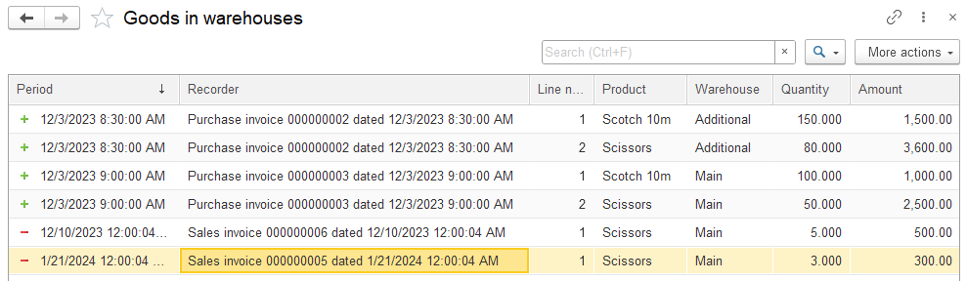
Let's look at an example: there is a table of register movements as in the image above. There are 3 movements for the item Scissors: receipt on 03.12.2023, expense on 10.12.2023, and expense on 21.01.2024.
A user wants to receive the quantity balance of this product on 15.01.2024 at the Main warehouse. To do this, the system selects the date of the calculated totals that is greater than or equal to the date of the required balances, this is 01.02.2024. Then gets the balance on this date from the totals table and then gets movements for the period from 15.01.2024 to 01.02.2024 from the movements table and removes them from calculations, in our case one movement falls within this time period. So the balance is 42, total quantity of movements is 3 (or we can say -3 because this quantity influenced the balance with a minus sign, because this is a movement with the Expense type). The total quantity is
42 - (-3) = 45
Turnovers
A virtual table of turnovers of the balance register always uses data from a movement table. It means that data from the movement table will be processed to obtain turnovers for a certain period, regardless of the period of the calculated totals. For this reason, it is necessary to choose the kind of register wisely - if you plan to receive turnovers frequently, you should create an accumulation register with the “Turnovers” kind.
BalanceAndTurnovers
The virtual table of balance and turnovers calculates both balance and turnovers simultaneously. Depending on whether the periodicity is specified or not, the way this table works changes. If the periodicity is not specified, then the data is calculated by a single query, which in turn contains subqueries. If the periodicity is specified, then 2 separate queries are executed, the results of which are combined.
Turnovers register tables
The totals table of the accumulation register with the Turnovers kind stores the calculated turnovers (movements grouped by register dimensions) with a monthly frequency. The totals are stored for all periods for which there were movements. It is impossible to obtain balances from such register data.
Let's look at a small example to better understand what the totals table of Turnovers register looks like. Let’s say our movement table of the Sales register looks like this:
Period | Product | Customer | Quantity
10/27/2023 1:12:51 PM | Screwdriver | Counterparty 2 | 80
10/27/2023 1:12:51 PM | Hammer | Counterparty 2 | 200
10/27/2023 1:12:51 PM | Axe | Counterparty 2 | 200
10/30/2023 10:46:23 AM | Hammer | Counterparty 2 | 22
11/25/2023 10:52:38 AM | Drill | Counterparty 1 | 30
11/29/2023 2:10:05 PM | Drill | Counterparty 1 | 12
1/11/2024 12:00:04 PM | Scissors | Counterparty 2 | 300
1/12/2024 10:02:01 PM | Scissors | Counterparty 1 | 500
1/24/2024 11:56:45 AM | Scissors | Counterparty 2 | 1,500

Then the totals table of the register looks like this:
Period | Product | Customer | Quantity
10/01/2023 12:00:00 AM | Screwdriver | Counterparty 2 | 80
10/01/2023 12:00:00 AM | Hammer | Counterparty 2 | 222
10/01/2023 12:00:00 AM | Axe | Counterparty 2 | 200
11/01/2023 12:00:00 AM | Drill | Counterparty 1 | 42
1/01/2024 12:00:00 AM | Scissors | Counterparty 1 | 500
1/01/2024 12:00:00 AM | Scissors | Counterparty 2 | 1800

The virtual table Turnovers can get data from movement or totals physical tables or from both of them depending on the specified period and periodicity. If the periodicity is specified and it is less than a month, then only the movement table is used. If the periodicity is not specified or is specified greater than or equal to a month, then the use of the totals or movements table depends on the specified period.
If a given period includes entire months, then the data for them is calculated according to the totals table, the data for rest is calculated according to the movements table. If the period is not specified, then the turnovers are taken for the entire time from the first to the last movement of a register, in which case the algorithm is the same - entire months are taken from the totals table.
Let's look at several examples of obtaining turnovers with a periodicity of Month for a period:
- 01.11.2023 - 30.11.2023 Turnovers will be calculated only from the totals table, since the period is a full month, no more and no less.
- 25.10.2023 - 15.01.2024 Turnovers will be calculated only from both totals and movement tables, full month 01.11.2023 - 30.11.2023 will be taken from the totals table, the other two periods (25.10.2023 - 31.10.2023), and (01.01.2024 - 15.01.2024) will be taken from the movements table.
- 25.10.2023 - 25.11.2024 Turnovers will be calculated only from the movements table, since the period doesn’t contain full months.
Getting data from virtual tables of the accumulation register
There are 2 ways to get data from virtual tables: using built-in code and using a query.
In the built-in language, you can use the Balance and Turnovers methods of accumulation registers to obtain balances and turnovers in the form of a value table. These methods allows us to specify a period, and filter to limit the selected data. You can also specify the dimensions and resources that will be represented in the resulting value table.
// Get quantity and amount balance of all products at all warehouses
GoodsBalance = AccumulationRegisters.GoodsInWarehouses.Balance(Date);

// Get quantity balance of all products at the "Additional" warehouse
Filter = New Structure("Warehouse", AdditionalWarehouse);
GoodsBalance = AccumulationRegisters.GoodsInWarehouses.Balance(Date, Filter, "Product", "Quantity");

// Get turnovers for one product for the current month for all clients
Filter = New Structure("Product", ProductForSearch);
SalesTurnovers = AccumulationRegisters.Sales.Turnovers(
BegOfMonth(Date), EndOfMonth(Date), Filter, "Customer");

The result that these methods return is a value table, where the columns are register dimensions and resources (their composition can be limited through the parameters of the methods).
Receiving balances and turnovers at the same time is not provided by the built-in code.
For a register with the Turnovers kind, calling the Balance method will cause an exception to be thrown:
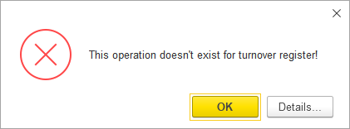
Retrieving data from virtual tables by query is a more popular method, since it allows complex selections, as well as joining and merging of data.
Balance virtual table
Let's look at a few examples, starting with getting Balance from the GoodsInWarehouses accumulation register.
In the list of tables in the AccumulationRegisters node, we should select the Balance virtual table of the register. Virtual tables have virtual table settings, a window with which can be opened by clicking on the gear button:
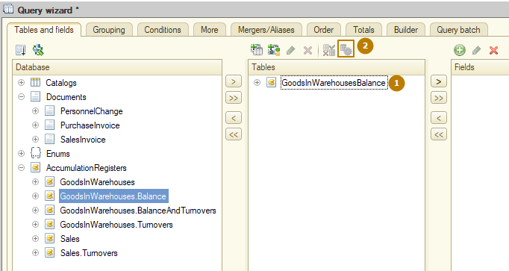
If the button is not available, select the table in the list of selected tables:
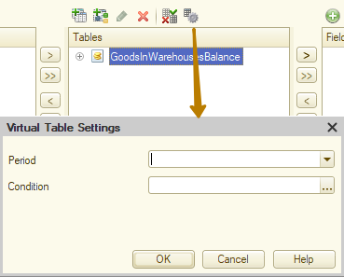
The Balance virtual table has only 2 parameters: period and condition. The period should indicate the date on which you want to receive the balances. If you do not specify a period, current balances will be obtained. Usually the period is specified by a query parameter (written as & symbol + parameter name).
We can use the "condition" field to specify any condition in the query language, as a rule, these are filters based on register measurement values. For example, if we need to select data for some specific products from one warehouse, we can set the following condition:
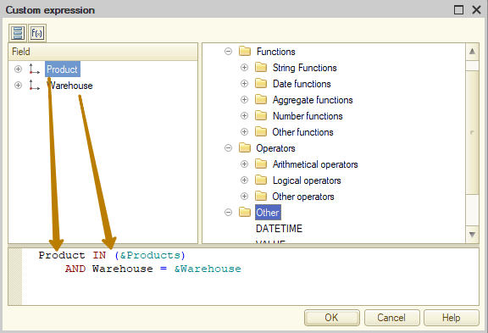
The result of virtual table settings:
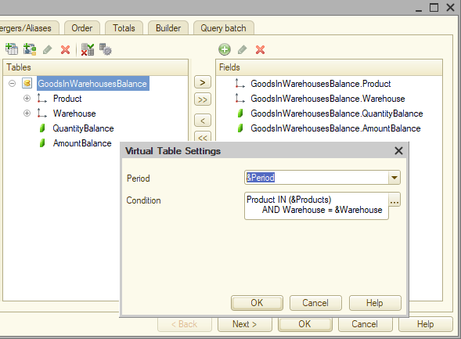
In condition you can use various comparisons, including checking whether values of dimension (dimensions) are included in the result of a nested query, for example, here is the text of a query in which document data is first selected into a temporary table, and then a condition is created to select only products included in this temporary table:
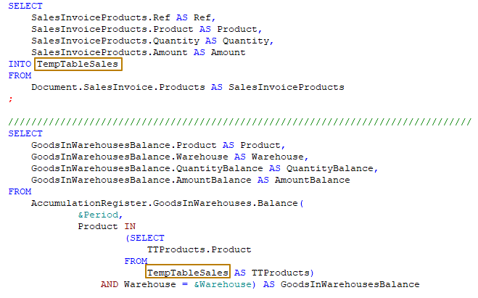
Note: Such a nested query must be written independently; it cannot be created using any constructor.
Turnovers virtual table
Let's move on to the turnover table. It contains more virtual table settings:
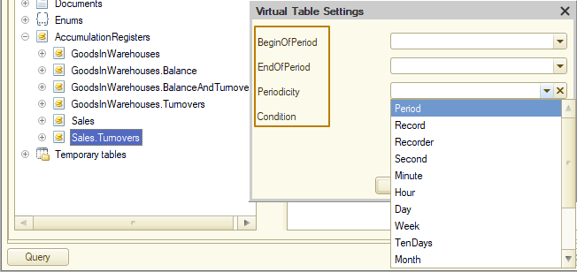
The period is indicated in two fields: BeginOfPeriod and EndOfPeriod; there is also a Periodicity parameter, which indicates to what frequency the table records should be grouped. Let's return again to the table of movements of the Sales register to understand how periodicity affects the result of selection from the Turnovers virtual table:
Period | Product | Customer | Quantity
10/27/2023 1:12:51 PM | Screwdriver | Counterparty 2 | 80
10/27/2023 1:12:51 PM | Hammer | Counterparty 2 | 200
10/27/2023 1:26:10 PM | Screwdriver | Counterparty 2 | 100
10/30/2023 10:46:23 AM | Hammer | Counterparty 2 | 22
11/25/2023 10:52:38 AM | Drill | Counterparty 1 | 30
11/29/2023 2:10:05 PM | Drill | Counterparty 1 | 12
1/11/2024 12:00:04 PM | Scissors | Counterparty 2 | 300
1/12/2024 10:02:01 PM | Scissors | Counterparty 1 | 500
1/24/2024 11:56:45 AM | Scissors | Counterparty 2 | 1,500
Let's imagine that we select data for the period from 01.10.2023 to 01.03.2024. The following are the selection results for different periodicity values:
Day
Period | Product | Customer | Quantity
10/27/2023 12:00:00 AM | Screwdriver | Counterparty 2 | 180
10/27/2023 12:00:00 AM | Hammer | Counterparty 2 | 200
10/30/2023 12:00:00 AM | Hammer | Counterparty 2 | 22
11/25/2023 12:00:00 AM | Drill | Counterparty 1 | 30
11/29/2023 12:00:00 AM | Drill | Counterparty 1 | 12
1/11/2024 12:00:00 AM | Scissors | Counterparty 2 | 300
1/12/2024 12:00:00 AM | Scissors | Counterparty 1 | 500
1/24/2024 12:00:00 AM | Scissors | Counterparty 2 | 1,500
Month
Period | Product | Customer | Quantity
10/01/2023 12:00:00 AM | Screwdriver | Counterparty 2 | 180
10/01/2023 12:00:00 AM | Hammer | Counterparty 2 | 222
11/01/2023 12:00:00 AM | Drill | Counterparty 1 | 42
1/01/2024 12:00:00 AM | Scissors | Counterparty 2 | 1,800
1/01/2024 12:00:00 AM | Scissors | Counterparty 1 | 500
You can see that as the periodicity increases, records with the same dimensions values are grouped into one record within a period (day, month, year, and so on), the period value changes to the beginning of the period (beginning of the day, month, year, and so on).
It is important to understand that records are not grouped by all register dimensions, but only by those included in the selection. For example, selecting turnovers for the same period with a monthly frequency but only for the “Product” dimension (look at the query below)
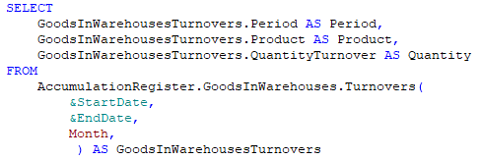
will return the following result:
Period | Product | Quantity
10/01/2023 12:00:00 AM | Screwdriver | 180
10/01/2023 12:00:00 AM | Hammer | 222
11/01/2023 12:00:00 AM | Drill | 42
1/01/2024 12:00:00 AM | Scissors | 2,300
You may notice that in this case the “Scissors” product is grouped for the month as a whole, regardless of which Customer was indicated in the records.
Note: If there were no turnovers for a certain set of dimensions in a certain period, a query to the Turnovers virtual table will not return records for that period for that set of dimensions. For example, in the table from our example there is not a single record for December 2023, which means that if we run a query for the period 01.12.2023 - 31.12.2023, the result will be empty (this means that the query result does not contain a single record).
Also, the result of a query to the Turnovers virtual table of register will be empty when the value of each of the selected resources for a set of selected dimensions is 0 (for example, a company bought 10 units of goods and sold 10 units of goods. +10 - 10 = 0), then the result of a query will not have records for such dimensions.
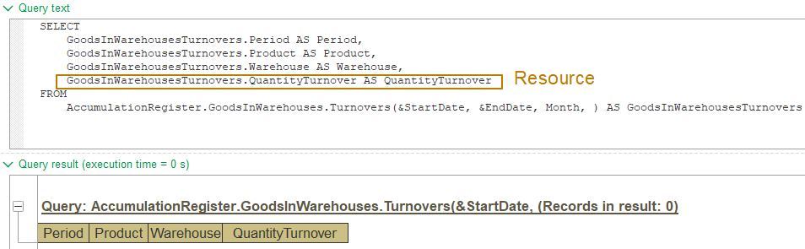
But if for at least one of the selected resources the value is different from zero, a query will contain records where one or more resources have a zero value, but there is at least one resource in each record where the value is different from zero.
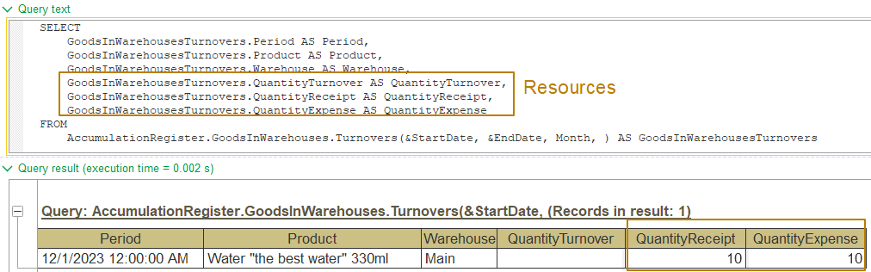
BalanceAndTurnovers virtual table
The BalanceAndTurnovers table allows us to obtain data on both balances and turnovers. Moreover, Balances can be obtained both at the beginning and at the end of the period; usually this information is used in reports when, for example, we need to see the quantity and amount of goods in dynamics: how much we had, how much has changed, how much has become.
Each register resource is represented in this virtual table by 5 fields:
- Opening balance (balance at the beginning of the period)
- Turnover (for the period taking into account periodicity)
- Receipt (for the period taking into account periodicity)
- Expense (for the period taking into account periodicity)
- Closing balance (balance at the end of the period)
This virtual table has one more parameter - ComplementMethod, which is used to indicate the inclusion of boundary periods in the records returned by the virtual table. If the RegisterRecords option is selected, then boundary periods will not be included (the query will only select records for periods in which there were movements). If the RegisterRecordsAndPeriodBoundaries option is selected, then boundary periods will be included regardless of the presence or absence of movements within the interval between the Start of the Period and the End of the Period.
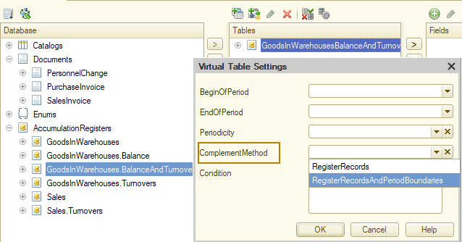
The result with the RegisterRecords complement method for the 01.11.2023 - 31.12.2023 period:
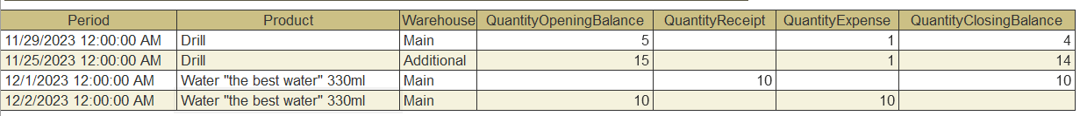
The result with the RegisterRecordsAndPeriodBoundaries complement method for the same period:
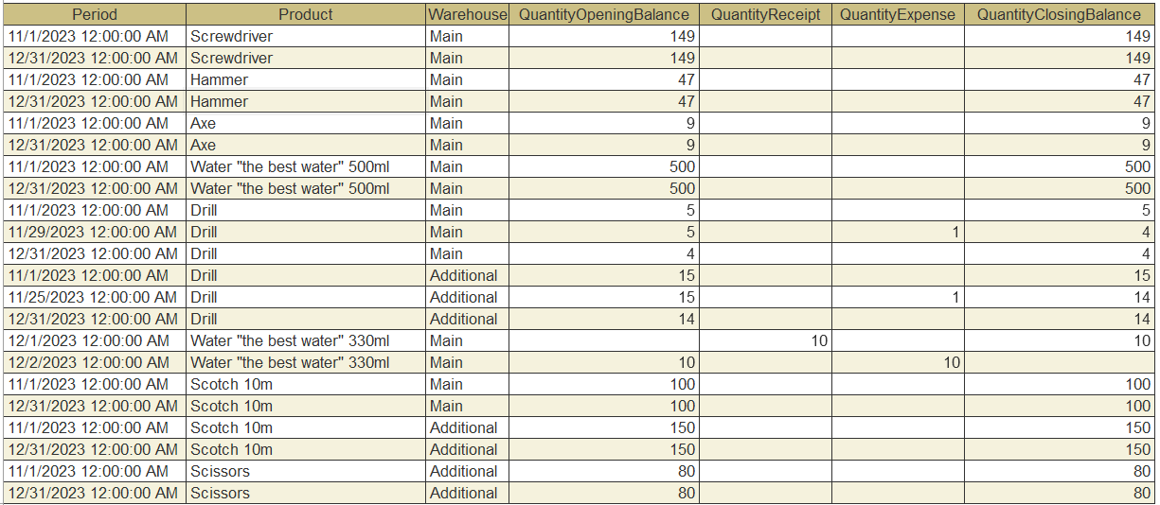
You can see that in first case the query result contains only records that had turnovers in the selected period, while in second case, the query result contains records for the beginning of the period and the end of the period, even if there was no turnover for the period for the set of dimensions.
Important: when working with virtual tables, you should always limit the selection of data as much as possible so as not to waste resources on unnecessary calculations.
What does it mean ? Since the operations in a query are performed in a certain order and the very first operation is to obtain data from a virtual table, not using filters in the virtual table settings will result in redundant data that we do not need and will be filtered out later.
Let's imagine that our database contains balances of tens of thousands of products in various warehouses. We need to receive the balances of 5 products from one warehouse.
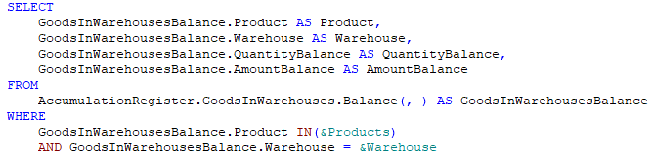
If we use selection in the WHERE section of the query, then the query at the database level will be executed in several stages:
- Balances for all products and warehouses from the totals table for the specified date will be selected (if the date is not specified, current totals will be selected), these can be tens of thousands of records
- From this table only records that meet the condition from the WHERE section will be selected
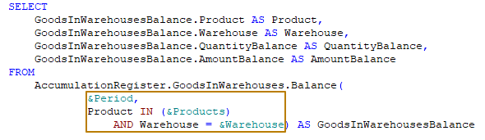
If we set a condition in the parameters of the virtual table, the required data will be immediately selected saving resources.
Document posting
In the previous topic about accumulation registers, we talked about the fact that the records of accumulation registers are changed using documents that are recorders for such registers.
But by what algorithm will these records be generated? Let's figure it out.
First, you need to determine which documents are recorders for the accumulation register. The opposite situation is also possible - you can specify for the document in which registers it can make records.
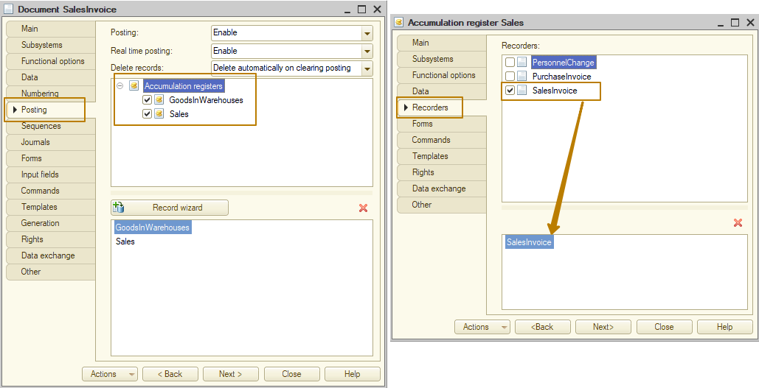
After this, you need to write code to add records to the registers for which the document is a recorder. The 1C platform provides the Record wizard tool for easily generating such code using a graphical interface. This tool can be opened from the Document object editor from the Posting tab, as well as by right-clicking on the document, then menu Wizards - Register record wizard.
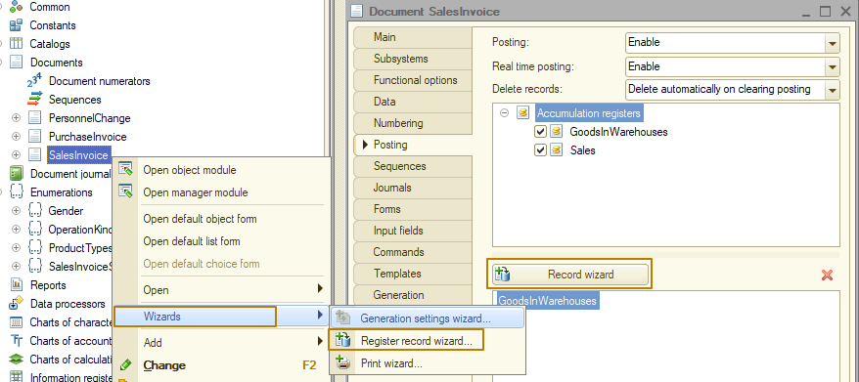
Typically, records to the register are performed from the Posting event handler procedure, i.e. the document makes movements into the registers at the time of posting. Let me remind you that the operation of posting a document itself is a sign that it is necessary to record in the system changes associated with the event that occurred. For example, when posting a Sales invoice document, sold goods must be written off from the warehouse, it must be recorded that the buyer owes the seller a certain amount of money as payment for the goods, and so on.
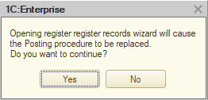
Let's see how to use the record wizard. If the document already contains a Posting event handler procedure in an object module, you will see this message warning you that this procedure will be completely replaced by code generated from the Record wizard:
At the next step, you will be asked to select the register in which you will generate the movements. At this step, you can select only one register
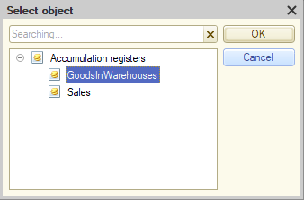
but directly in the wizard you can add the remaining registers and describe the generation movements to it:
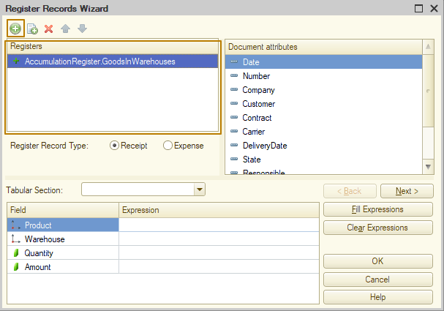
You can see the difference between the kinds of registers using different icons; also, a register with the Turnovers kind does not allow you to specify the type of added movements (receipt, expense):
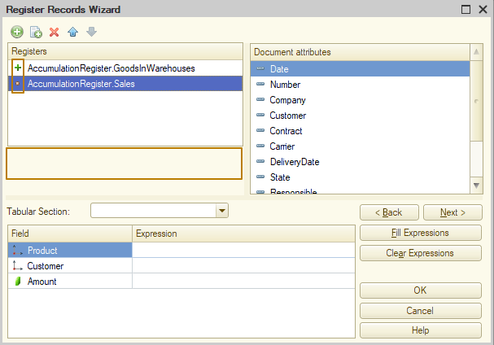
When generating movements in several registers, you should sequentially fill the lower list (a list with an algorithm for filling register records), selecting registers from the upper list.
The easiest way to fill in the register fields is to use automatic filling: the document fields that match the names of the register fields will be used by the platform. If the document contains a tabular section, you must first select it so that the attributes of this tabular section appear in the Document attributes list.
Next, to automatically fill, click the Fill Expressions button. After this, you can add/edit register fields in one of two ways:
1) select a field and double-click on the available field from the list
2) write the expression directly into the Expression column of the list of register fields.
Don’t forget to select the right register record type (Receipt, Expense)!
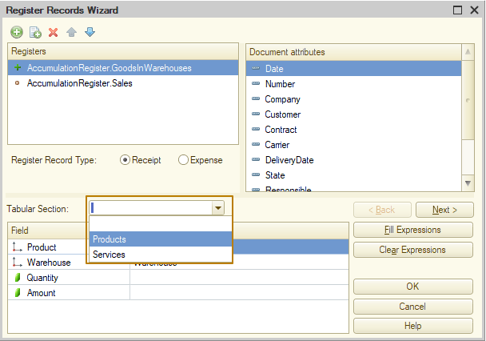
Since the Sales invoice document reflects the sale, the goods indicated in it should reduce the balance of a warehouse. That's why I change the record type register on Expense. So, I filled in the movements in 2 registers, let's look at the result, for this I press the OK button:
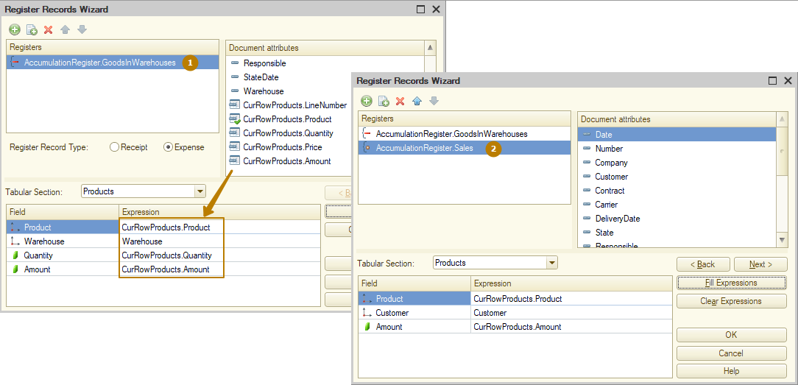
I end up in the document object module, where the Posting procedure is created (or refilled), in which the code for creating movements in registers was created using the Record wizard.
You may notice that at the beginning and end of the procedure, the platform left service comments stating that the code fragment inside the comments was created using the Wizard, and all manual changes will be lost the next time the Wizard is used. Every time you use the Record wizard and click OK, the Posting procedure code is completely replaced, even if you have not made any manual changes. For example, you described movements in 5 registers by a wizard, then used a wizard second time and described movements in only 1 register (and forgot the rest). In this case the code for creating movements in the remaining registers will be lost. So be careful using Record wizard when the Posting procedure already exists.
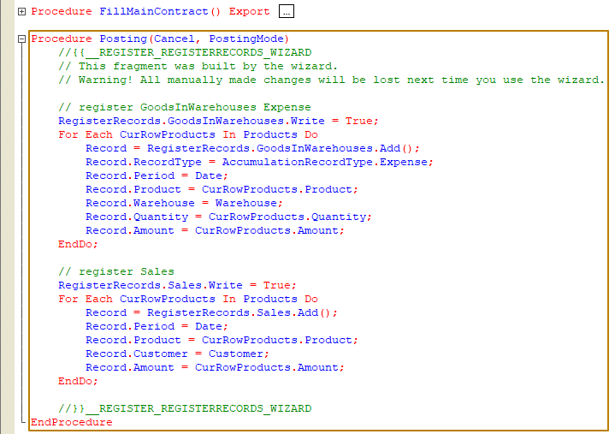
It's time to look at the resulting code and figure out whether it is optimal. There are 2 drawbacks:
1) The Record wizard does not allow you to make movements into registers from several tabular sections of the document at once. For example, the Sales document contains tabular sections Products and Services, but I could only select the tabular section Products. Accordingly, I need to describe the creation of movements in the tabular part of the Service myself.
2) Iteration of the same table section is not combined for multiple registers. You can see in the image above that there is an iterating the Products table section twice - once for each register. This doesn't make sense, we can optimize this code so as not to perform redundant operations. Therefore, I will transfer the code for recording movements to the Sales register, and I will change the code for iterating the Products tabular section a second time so that we iterate the Services tabular section, since sales of services should also be written into the Sales register:
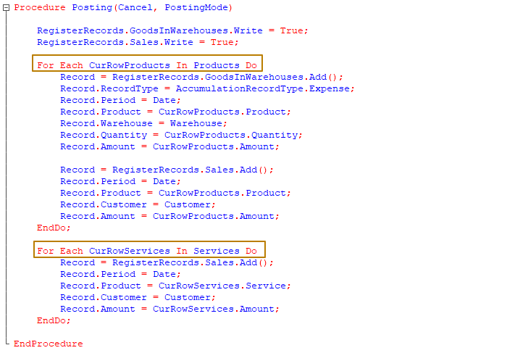
Let's try to understand what the lines of code generated by the Record wizard do. RegisterRecords is a special collection containing sets of records of all registers for which this document is a recorder. You can access a record set of a specific register as a property of the RegisterRecords object by its name, for example RegisterRecords.Sales, RegisterRecords.GoodsByWarehouses.
The Write property of a register record set has the following purpose: after the executable code exits the Posting procedure, those record sets whose Write property is still set to True (default value is False) will be automatically written by the platform. If there is a need to record movements before the end of the Posting procedure, this can be done using the Write() method (the method name is the same as the property name, but parentheses are always used after the method name):
// This is a method
RegisterRecords.Sales.Write();
// and this is a property
RegisterRecords.Sales.Write = True;
Posting mode
Let's talk a little about the document posting mode. There are 2 types of posting modes: real time and regular (backdated). Real time posting occurs under the following conditions: the document's metadata object properties include the properties "posting", "real time posting" and the date of the document at the time of posting - today. In this case, the platform will automatically change the document time to the current one.
Posting documents in real time is used where timing of an operation with an accuracy of up to a second is very important, for example, the sale of goods at retail, because the possibility of completing a sale is influenced by many factors, here are some of them:
- in some countries it is prohibited to sell alcoholic beverages after a certain time
- business lunch is sold at certain hours
- when several cash registers operate in parallel, it is necessary to monitor the balances of bonus points, client gift certificates, remaining goods in the warehouse, and so on
- we are have to send electronic checks to the government system. Checks are accepted only for the last week, so if we enter a receipt for an earlier period, its electronic version will be rejected by the system.
It should be understood that the time will be adjusted to the current second when posting a document forcibly, so it is recommended to disable real time posting for those documents for which real time posting is not required.
There are also service documents that are not a reflection of real operations or events; for some of them posting does not make sense. This is why it is possible to disable posting for a document.
Features of date and time when working with documents and registers.
Date
There is one more thing to note regarding the date of documents: since there are no restrictions on entering documents on the same date/time, there is a risk of receiving inaccurate balances as of the date of one of these documents.
The developer must take this feature into account when developing algorithms for obtaining balances/turnovers using register virtual tables.
Let's look at an example: in our system there are 4 Sales Invoice documents for 10.01.2024. These are the documents:
- Sales invoice 0001 dated 10.01.2024 01:12:13 PM
- Sales invoice 0002 dated 10.01.2024 01:12:14 PM
- Sales invoice 0003 dated 10.01.2024 01:12:14 PM
- Sales invoice 0004 dated 10.01.2024 01:12:14 PM
Documents are entered into the system sequentially from #0001 to #0004; when posting each document, it is necessary to check that there is a sufficient quantity of goods in the warehouse.
Now we get to the core of the problem. The Balances and Turnovers virtual tables use dates passed to parameters in different ways: the Balances virtual table, for which the period is specified by a Date type value, receives data for the date BEFORE the second specified in the parameter. The Turnover virtual table at the same time receives data including the seconds specified in the BeginOfPeriod and EndOfPeriod parameters by values of the Date type.

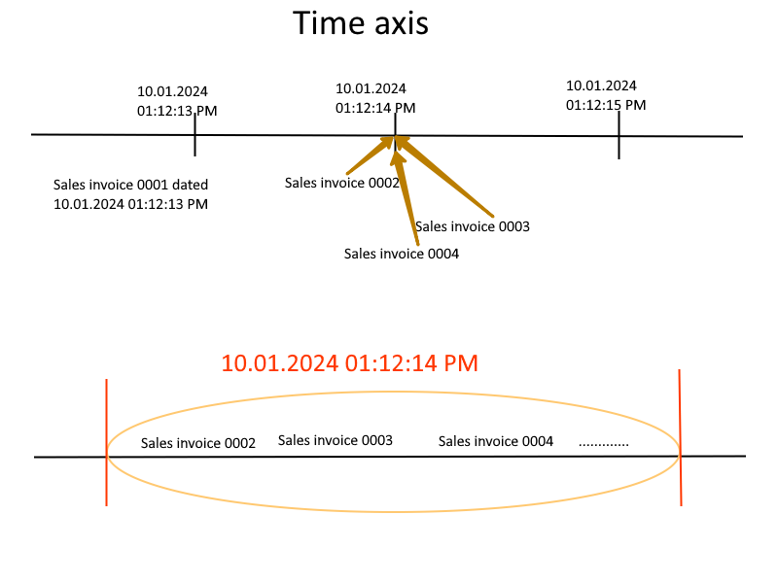
This means that when the user posts these documents sequentially, then starting from document 0003, control of balances on the document date will not take into account other documents on the same date - 10.01.2024 01:12:14 PM, because as mentioned above, the table balances receives data for the date BEFORE the specified second.
PointInTime
The 1C platform has a separate value type so that you can work with objects on the time axis in more detail. This value type is PointInTime. A value of this type can be generated manually or obtained using the PointInTime() method. PointInTime consists of two parts: a date and a link. This brings us to the fact that even if the date matches up to a second, the documents still have their own order on the time axis - some documents are located earlier, others later. Thus, if you pass PointInTime instead of a date to the Period parameter of the Balance virtual table, then the balances will be received at the moment right before this PointInTime, i.e. just all balances on the date of the document without taking into account this document itself:
Query.SetParameter("Period", ThisObject.PointInTime());

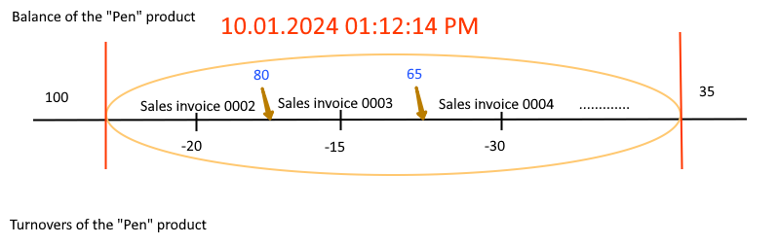
If we receive balances as of the date of documents 0002, 0003, 0004, then the balance for the “Pen” product will be the same - 100 pieces. If we receive the balances of each of the documents, then for document 0002 it will be 100 pieces, for document 0003 - 85 pieces, for document 0004 - 65 pieces.
PointInTime can also be generated manually from a date and a link:
PointInTime = New PointInTime(DocumentOrAnyOtherDate, RefToDocument);
What if we need to get data accurate to the second, but including all movements within that second? Of course, we can get the remainder for the next second after the one we need
Query.SetParameter("Period", DocumentDate + 1);
but such code can mislead other developers, and even us after some time, when it will be difficult to remember why we wrote such code.
Boundary
For the purpose of clarifying the inclusion or exclusion of boundary values for a period in 1C, there is an object of the Boundary type:
Boundary = New Boundary(DocumentDate, BoundaryType.Including);
Query.SetParameter("Period", Boundary);
We can also use a boundary if we want to exclude movements for a certain second while receiving turnovers, for example:
StartDate = Date(2024, 01, 10);
EndDate = New Boundary(DocumentDate, BoundaryType.Excluding);
Query.SetParameter("StartDate", StartDate);
Query.SetParameter("EndDate", EndDate);
And we can even combine the Boundary and the PointInTime in order to get the balances on the point in time, including the movements at that point in time:
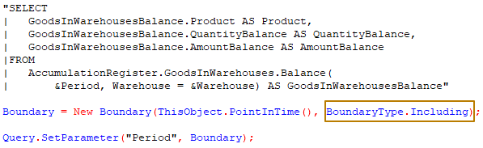
Features of document writing
Note the difference in some mechanisms between interactive mode (when the user performs some operations in Enterprise mode) and programmatic mode (when some operation is performed from code).
When you create a document form, the RepostOnWrite property is enabled by default. This means that if the user saves an already posted document from such a form, the platform will re-post it.
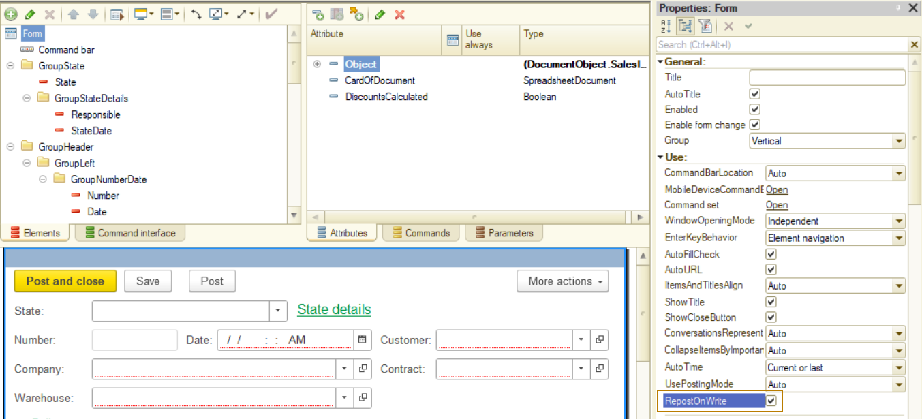
Recording a document from code works more clearly - for recording, the Write() object method is used, which has 2 parameters:
- WriteMode - allows you to select the recording mode from the options Posting, UndoPosting, Write
- PostingMode - allows you to select a posting mode from the options RealTime, Regular
Examples:
Write(DocumentWriteMode.Posting, DocumentPostingMode.RealTime);
// The method has default values for both of the parameters:
// Write mode = Write, Posting mode = Regular
Write();
Let's look at an example of programmatically creating and writing a document to better understand how to work with reference objects (directory, document, etc.) from code. To do this, in the list form of the Sales Invoice document, we will create the “Copy and Post” command, by clicking which the selected document will be copied and posted in real-time mode
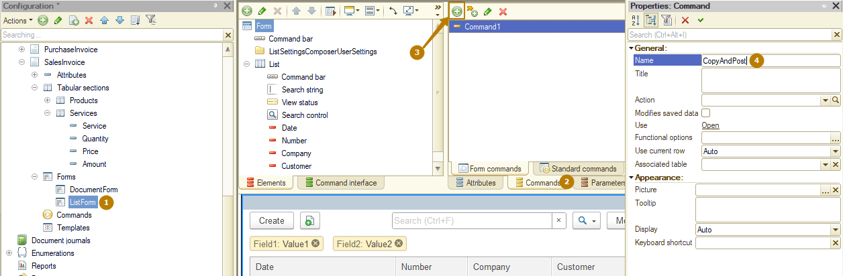
Let's add a button associated with this command to the command bar of the form. Next, you need to create a command handler procedure, click the magnifying glass button in the Action property and select "Create on client and a procedure on server".
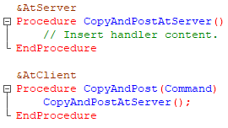
Now we need to fill the server procedure with code. The object and the link to the document have a Copy() method that creates a new object that has not yet been written to the database. We can work with this object to fill its attributes and table sections, we can call methods located in its object module, we can pass it to other methods, and so on.
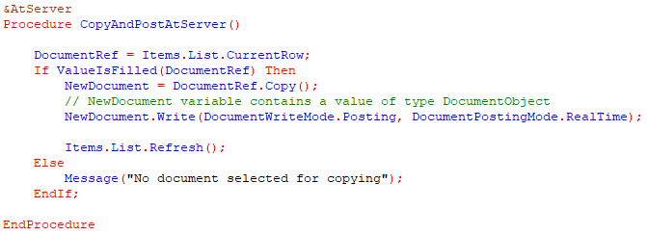
The main thing is to write the object after the changes are completed, otherwise all changes will be lost.
To see the new document after it has been added programmatically, we must refresh the list. To do this, the form table has a Refresh() method.
Note: In a list form, the main attribute is the dynamic list. For a form element of the Table type associated with an attribute of the dynamic list type, the value of the CurrentRow property differs from the value of this property. So, if the main table of a dynamic list is a table of a reference object, then the CurrentRow property contains a link to the object selected in the list, or Undefined if no row of the list is selected (usually this is only possible if the list is empty). In tables associated with attributes of other types, the CurrentRow property usually contains the row identifier (number).
Additional properties
Let's take a look at an auxiliary tool for transferring data within different event handlers and methods of an object - this is AdditionalProperties property of an object. These can be either reference objects (Catalog, Document, and so on) or non-reference objects (Information register record set, accumulation register record set, and so on) .
This object has the Structure type and allows us to store and transmit additional information for further use when working with the object. One of the usages is to pass data to an event handler that is not available to it, but is available to the handler of another event. For example, we can’t check if the document is new at the Posting event handler. This is because the Posting event occurs when the object is already written to the database, therefore the platform will not consider it new, because there is a link to it. Typically, such a check is performed in the BeforeWrite event, when the object has not yet been written to the database:
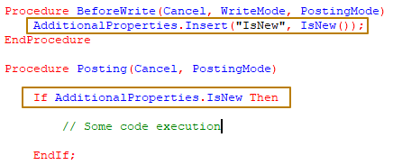
The IsNew() function returns True for a new object and False for an object already recorded in the database. Only reference objects have this function.
Generation
In 1C it is possible to generate one object based on another. This makes it easier to fill out a new object, because you can not only transfer data from the basis document, but also describe an algorithm for filling an object depending on various conditions, for example, based on what type of object the generation was performed on. This feature simplifies and speeds up work in the program for the user.
Let's see how it works with an example. I will create a ReturnOfGoodsFromCustomer document that allows us to reflect the return of goods and configure the ability to generate it based on the SalesInvoice document.
- To do this, in the object editor, you need to go to the Generation tab, in the “Generated based on” list click the button for selecting metadata objects, select the needed objects (there can be as many of them as you like, but in my case it’s only the SalesInvoice document) and click OK.
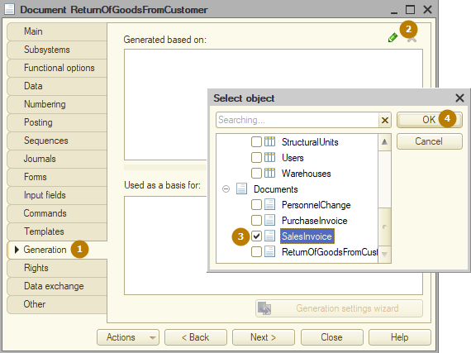
After this, it is necessary to describe the filling algorithm in the Filling event handler of an object. This Filling event occurs in several cases:
- when interactively creating a new object
- when generating a new object based on another object
- when programmatically calling the Fill() method of an object
To simplify the creation of a filling algorithm, you can use the Generation settings wizard tool
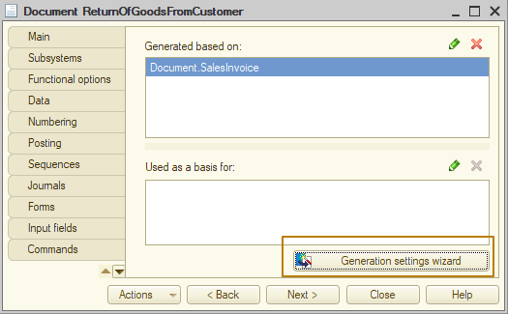
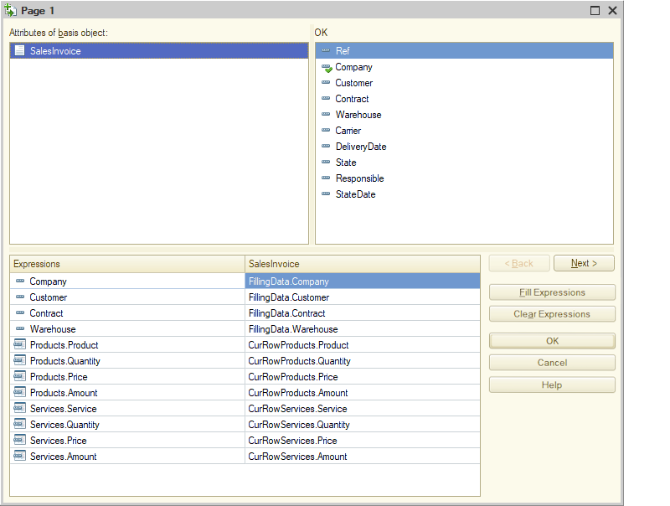 The window that opens resembles a record wizard in appearance and set of commands. Here you need to specify the algorithm for filling out the fields for each of the basis objects. You can use the Fill Expressions button to fill in object attributes and table sections that match the name. After clicking OK, you will be taken to the document object module, where the Filling() event handler procedure will be created and shown open. Here, as in the case of using the Record Wizard, the platform adds service comments warning that the code was generated by the wizard and will be replaced entirely the next time the Generation settings wizard is used:
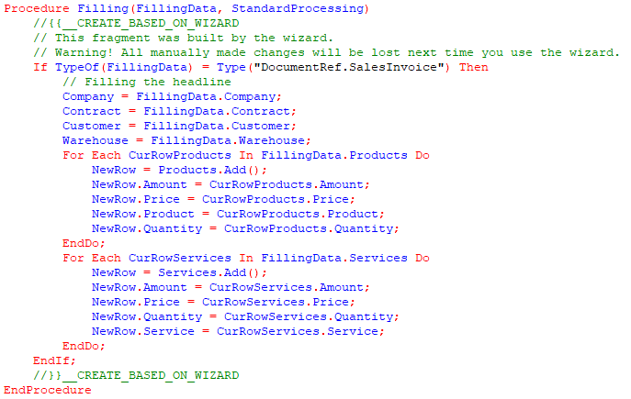
Now I will update the infobase configuration and launch the database in Enterprise mode. Now I will update the infobase configuration and launch the database in Enterprise mode.
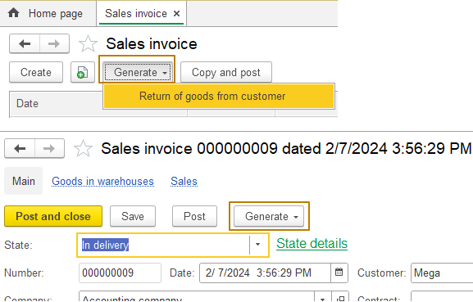
As you can see, in the list form and the SalesInvoice document form, the Generate submenu has appeared, in which there is a button with the name of the document that can be entered based on it.
I'll try to generate the return document. As a result, the form of a new document opens, which is already completely filled out.
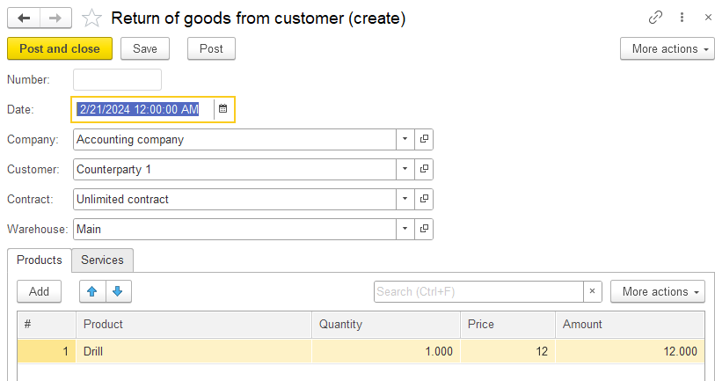
In the case of returning goods, we must leave in the document only the goods that the client is returning/has returned.
I draw your attention to the fact that the return document must be somehow connected with the sales document, otherwise it will be difficult to understand on the basis of which particular Sale the Return operation was entered. To do this, I should create an attribute in the document that will store a link to the basis document. I will name this attribute SalesDocument and specify its type DocumentRef.SalesInvoice:
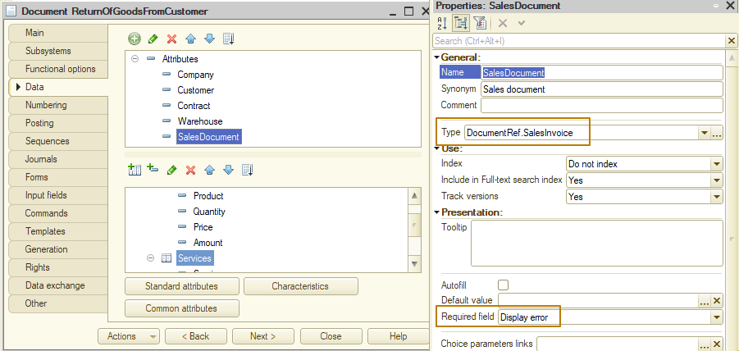
Next, I need to add code to fill this attribute in the Filling event handler:
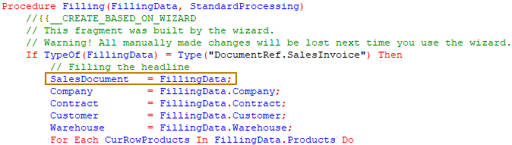
Finally, I create a document form and make the field associated with this attribute unchangeable. Since it will always be unavailable, but the user may need to open the sales document from the return document, I want to make the field a hyperlink. To do this, I need to select the field type "Label Field" and enable the hyperlink property:
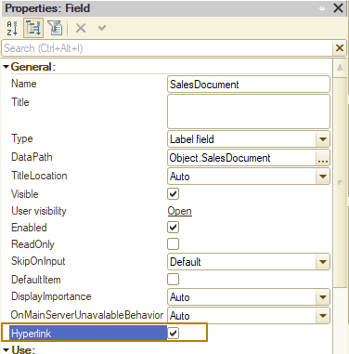
As a result, clicking on this hyperlink opens the SalesInvoice document form:
